S0020D Android Game and Application Development
LP3 V12

Image Viewer Application
ASSIGNMENT 2

Nimmagadda Radhakrishna Kalyan
radnim-1@student.ltu.se
2012-03-26

Table of Contents
Introduction 2
PART 1 – CONTENT ORGANIZATION 2
Organizational Schemes 2
Organizational Structure 5
Navigational Scheme 6
Search Scheme 12
Page-Level Navigation Support 14
PART 2 – Group and Case 16
Conclusion 17
References 18

Introduction

The primary objective of this report is to present the analysis of content organization of the website www.amazon.com. As per the requirements of assignment, thorough analysis of website’s organizational schemes and structures, as well as search and organizational schemas were conducted using the examples from the website itself. As a result of that analysis, suggestions for possible improvement were included in this report.
The report’s secondary objective is to kick start the work on the next assignment by documenting its preparations, including the choice of website which the group found interesting for the project.

PART 1 – CONTENT ORGANIZATION

Organizational Schemes

Every website needs a good organizational scheme to make the website more user-friendly, so as to make the user of the website more comfortable to browse through and find what he or she is looking for. If the website is not designed on a basis of good organizational scheme the user will get frustrated and this in-turn brings down the company or organization.
The website www.amazon.com (2012) utilizes a hybrid organizational scheme. As per the book Information architecture for the World Wide Web, (see reference) hybrid organization schemes are a blend of other types of organizational schemes. This hybrid-scheme includes elements of Audience- specific, topical, metaphor-based and task-oriented schemes.
In Topical Scheme based designed websites, the content of the website is divided into different topics, so that the user can access the content easily. Amazon (2012) has incorporated this scheme into its organization structure. When a user opens the website, the user can observe that the content is organized in different topic based navigation.
One can observe from fig 1 that different items are placed in different topics or departments.
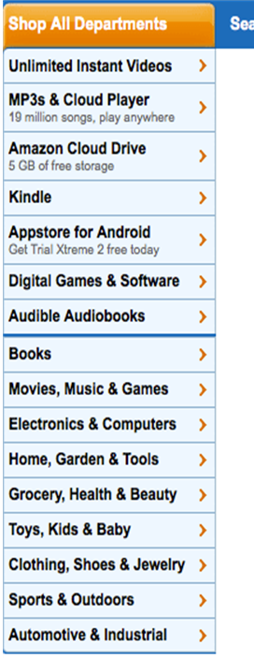
Example: if a user wants to buy a book, one can directly click on “Books” department and furthermore this department contains more options that the user can choose (see fig. 1 and fig. 2).
And once the user decided which type of book the user want (audio book, e-book, hard copy) he can continue with the purchase.
The other best example of topical scheme is when the user wants to buy a book; the website presents the book categories to choose from.

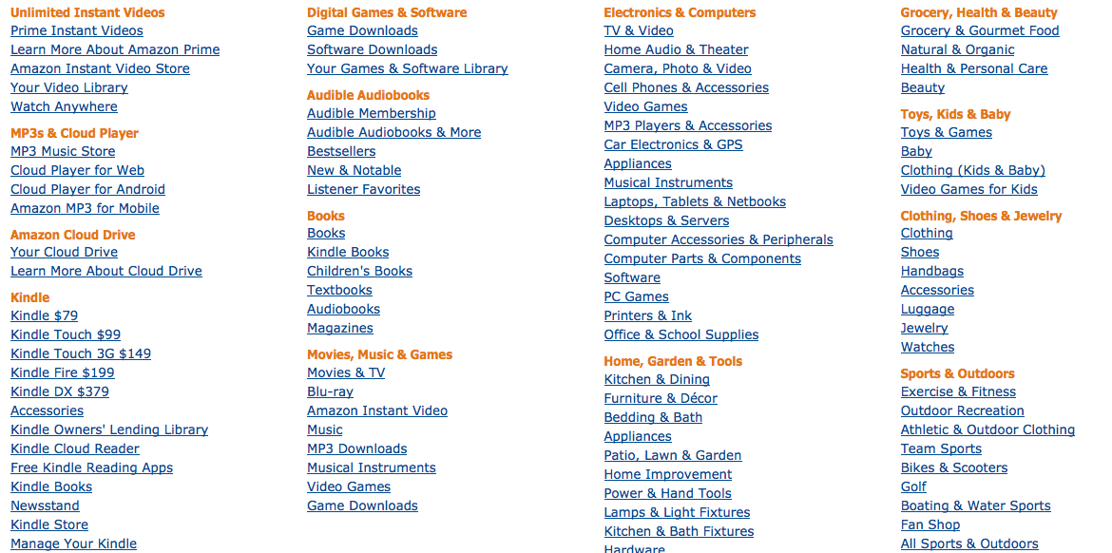

Fig. 1 Departments

Fig 2. Hyperlinks Navigation

In Audience-specific Scheme based website, the user can easily find the items related to appropriate user age. In Amazon website, developers have used best way of using the audience specific scheme in some of the departments like books.
Example: When a user visits the amazon.com (2012) home page and wants to buy a book, the website gives the genres which are divided into specific groups as children books and other genres. Also they divided the content based on age group. As one can observe in the picture below, the books for children are divided into age appropriate content, as kindergarten, teen choice etc. (see fig 3.).


Fig 3. Books categories by age group

Task Oriented Scheme is the scheme in which the design of the website is based on one specific kind of task, as e-commerce or user-interactive website.
By taking one glance of Amazon website, one can easily get that one can buy and sell the items. But more emphasize is given into offer the user a chance to buy different items, from books to automation needs. Please refer to fig-4
Example: In the ‘Books’ category, an option is provided to sell the books. And user can buy a book though many options for payment.

Fig 4. ‘Books’ category navigation top navigation

Metaphor-based Scheme is a scheme in which developers use metaphors (Metaphors are commonly used to help users understand the new by relating it to the familiar, the best example for metaphors are Computer, Folder and Recycle bin icons on desktop of a windows computer, with just one look user can understand what that particular application can be used for). Amazon uses the metaphors in a best way. In home page itself one can understand that this site offers wide variety of items for sale without having to do any search.
Example: If the user wants to buy some electronic items like cameras, camcorders etc., user can easily find them by looking at the metaphors as in the following figure. (see fig 5.). By looking at the metaphors user or buyer can easily understand what type of accessories (lenses, bags & cases) can be found in each type of category. So if the user wants to buy a camcorder he /she can directly click on the image of camcorders, which will present the different types of camcorders that amazon.com site offers for sale.
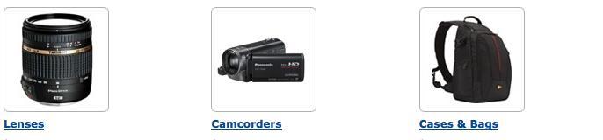

Fig 5. Weblinks using images as metaphors

Organizational Structure


Organizational structure plays an important role in designing the website. Once the kind of content that is relevant to the website is decided then how to structure the website will be the question of importance. Amazon website uses all structures i.e., Hierarchical, Hypertext and Database model based.
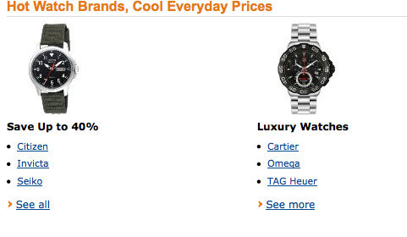

Fig 6. Link to seller page on product title

Fig 7. Hypertext organizational structure for watches

Hierarchical Structure can be achieved in different ways. One of them is Broad-Shallow Structure and the other is Narrow-Deep Structure. Amazon utilized both of these in a very sophisticated and well-designed manner depending on the need. In fig 2, we can observe how Amazon developers have used the Broad-shallow Hierarchical structure. But in the home page when first time user visits the website, the navigation is shown in Narrow-Deep structure as per fig 1.
Amazon website utilizes the Hypertext organizational structure for best benefits. Whichever page the user visits, that page has so many hypertext links that helps the user to navigate through the website with ease .
Example: If the user wants to buy a watch, he can easily go to the specific page of designer watches by clicking the hypertext links (see fig 6.).
The other structure that Amazon developers have utilized is Database Model driven Organizational Structure.
Example: If the user wants to search for the watch, then he/she can search by the brand (see fig 6.) or even by clicking the name of the seller (see fig 7.).

Navigational Scheme

According to Peter Morville & Louis Rosenfeld (2006), if structure and organization is all about building rooms, the navigation design is about building doors and windows, which is to say that the navigational scheme is a visual representation of content’s organizational structure. Effective navigation is crucial in making a user’s Web page browsing experience a pleasant one. In the fast changing and competitive world of today, even glitches on the user’s way towards the desired content/information, let alone complete disorientation, could mean a loss of a potential customer to a rival company with a site navigation system which is more appealing to the way the user thinks.
The purpose of the navigation system can be defined as the website making it possible for the user to know where he is, where he’s been and where he can proceed further on into the Web site. In order to achieve that objective the navigation system relies heavily on context organization and structure. It takes both the intuitive context structure and the navigation system which fits the structured content for a successful navigational solution.
Morville & Rosenfeld (2006) define several elements that can comprise a navigation system. The global, local and contextual navigation are integrated within the web pages themselves and are therefore called the embedded navigational system. The supplemental navigation systems are defined as those that exist outside the content-bearing pages, like sitemaps, indexes or guides. Sitemaps provide the map of the whole site, while indexes provide direct access to content. Guides are often organized in linear (vertical) fashion and provide navigation which is narrowed to a specific topic/task/user group.
The navigation systems can also be divided by the technique they use to navigate the site:
- Hierarchical, which derive from organizational structure
- Ad hoc - hyperlinks
- Database – search engines
And by navigational elements:
- Navigation bars(horizontal and vertical)
- Menus
- Drop-downs or pull-outs
- Ad hoc links
- Breadcrumbs
- Sub-sites
It is usual for a large enterprise site to use a combination comprising of most, if not all, the above mentioned elements. www.amazon.com (2012), which is the subject of this assignment, is one such site
Most users prefer broad and shallow hierarchies, which is the way amazon’s global navigation system is organized, in the form of a horizontal bar (see fig 8.).

Fig 8. Amazon.com Main menu

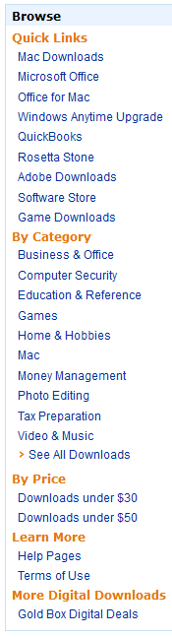
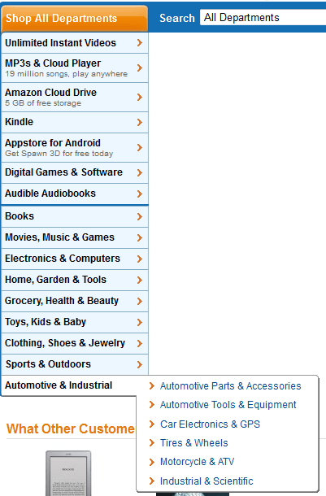

Fig 10. Local navigation for Electronics section

Fig 9. Local navigation for homepage

Wherever on the site the user happens to be, this is the bar which is always visible, containing a link to the main page, links to sign in/logout/account information, cart function links, and a database search engine with input text box, even containing a drop-down menu for narrowing the search right there on the global navigation bar.
On the left side of the main page lies a local navigation system in the form of vertical menu with drop-down menus per every item (see fig 9.).
Upon selecting an item in a drop-down menu, a sub-site opens and a new local navigation menu appears in the place of the previous one, but comprised of links, without ‘hover over’ drop-down menus and a slightly different visual design to emphasize that (see fig 10).

Alternative local navigation system appears just below the horizontal global navigation bar in the form of horizontal menu which visually appears glued to the bar, and is specific for the sub-site the user is currently on (see fig 11.).

Fig 11. Alternate local navigation below the main menu bar

The center of the main and subsequent pages is reserved for contextual navigation in the form of ad hoc links to product (see fig 10.), which are organized in rows according to bestselling products, special offers and other criteria that Amazon deems fit for the moment. The lowest row incorporates a sub-list of top selling items of the recently visited item type. Horizontal scroll buttons shows the next/previous row of the sub-list
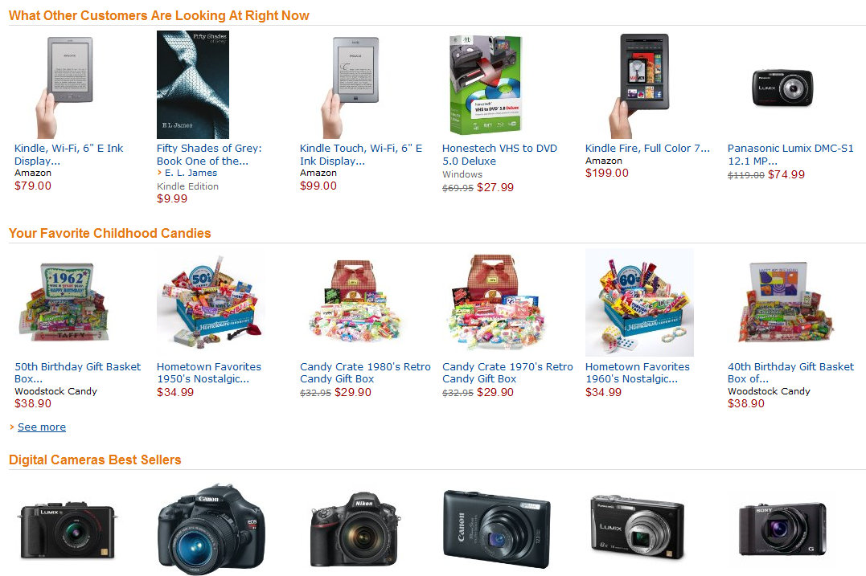

Fig 12. Links to ‘other’ products

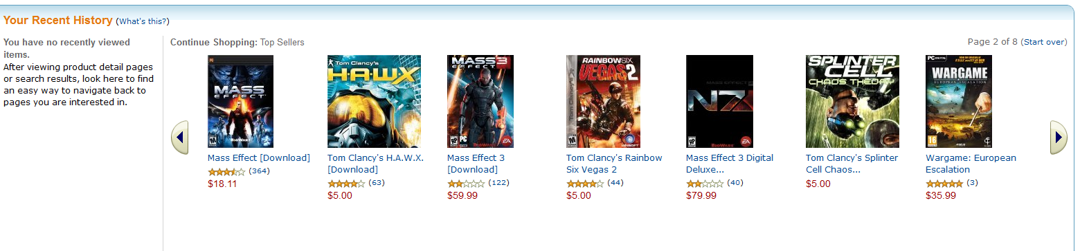

Fig 13. Recently viewed items

A list of the vertically organized ad hoc links follows (see fig 14.). Those links are not of interest to an average user and are therefore positioned discretely out of the way from the main context, described above, and are designed accordingly.


Fig 14. Ad hoc links on page footer

The recent history group of links which lies on the left side of the sub-list is as close as Amazon gets to “breadcrumb” navigational scheme element on the main page. It offers only ad hoc links to the products which were recently viewed by user. The subpages further down the site hierarchy offer a vertical link menu on the left side of the page which offers full “breadcrumb” functionality, with links that makes navigation possible at a click of the mouse. That is an elegant solution because it is there, in the navigation between masses of product types and subtypes, where that function is really needed. Even a classic “breadcrumb” horizontal bar at the top of context area shows when venturing into the product sub-pages, which offer both the user’s position information and a navigational functionality, on the more basic level then the abovementioned vertical menu.
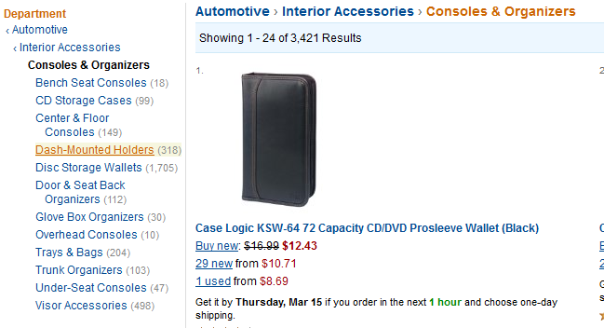

Fig 15. Product article for a CD/DVD case

An unusual combination of the site map and possibly sponsored ad hoc links is placed at the very bottom of the page. It can barely be called a site as it offers only links to Amazon sites which are relevant for several countries outside USA, which definitely have the same organizational structure, but different content.


Fig 16.

www.amazon.com (2012) offers a very pleasant user experience with intuitive navigation that makes navigating the site amazingly easy, which is probably why Amazon has stayed on top of the e-commerce business for so long. The secret behind that easiness is embedded navigation. Global, local and contextual navigation schemes seem quite Spartan when viewed independently, but as a whole they complement each other to compose a powerful navigational scheme.

Search Scheme

The anatomy of a search system might seem simple at a glance. The user sees a search text box, submits a query and gets the result. Without even going into explaining purely technical stuff behind a search, such as search algorithms, the search design in itself is something books have been written about. The first step in designing a search would be defining what to search. This is done by indexing the content and choosing search zones – focusing a search on right content type. An example of that would be sorting out navigation pages out of the search results, as the destination pages are the ones that actually contain the search objective. Indexing can be done according to many criteria, such as specific audiences, topics, recent content. Algorithms can be used to retrieve results with various precision and query builders such as spell-checkers, phonetic tools, stemming tools, natural language processing tools and controlled vocabularies and thesauri are used to enhance a query’s performance. Presenting results is a story in itself, how to distinguish two or more results which are similar, how many results to show per page and how many information to show per result, how to organize/sort the results, possible actions after retrieving them are all valid questions which stand before a Web designer.
At www.amazon.com (2012), the search text box is located on the horizontal navigation bar, as a part of the global navigation system of the site (see fig 17.). Testing has revealed that a spell-checker, automatic stemming and controlled vocabulary query builders are up and running. The box rolls down to reveal a list of completion recommendations which even include department selection, as a testament of extremely thorough indexing. To the left of the search box, lies a drop-down menu which functions as a search zone selector. On the main page, a search can be focused through that menu on a specific department. To the right of the search box, a “go” button is there as one of the options to start a search, besides selecting a recommended result with a mouse or striking “Enter” on the keyboard.

Fig 17. Product search box
The presentation of the results is closely integrated with the navigation scheme. Results are presented in the middle of the page as links to their own sub-pages. The presentation contains an impressive amount of information, according a relatively large photo of the object, information about pricing, shipping, availability, and user rating which at the same time represents a link to detailed user reviews of the product in question. Sorting of results is possible with a small drop-down menu according to relevance, popularity, price and user rating. Refining of the results is easy to achieve by using local navigation system on the left side of the page, which now not only contains those already described navigational links which could alone be used to focus the search on a specific product subtype, but also check- and text-boxes which can be used to filter the results. Parameters that can be specified are product characteristics, manufacturers, rating, condition, sellers and price. The best thing with a check-box solution is that all those filters can be applied at once and that they are not mutually exclusive.
It is per example quite possible to select products of three different manufacturers with one important (for the user) product feature, in the selected price range. Amazon displays 24 products page by default, but that can be changed under user preferences upon creating a user account. Even the first layer of results is presented in a way that radiates quality. Product pictures are big and detailed which, along with product information that accompanies them, allows the user to make an informed decision whether the product interests him or not.
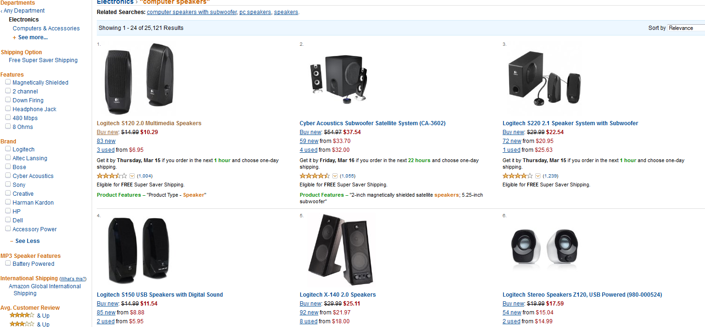

Fig 18. Collection of product articles

It is said that a user’s Web site experience is defined by navigational and search schemas, which are crucial in user’s effectiveness in finding the desired piece of information. Schema’s interaction between themselves and subsequently with user can be a shortcut or an obstacle towards that goal. Many Web sites, owned by large companies, even in the IT branch, have failed terribly in that aspect because with all their knowledge and technology, they did not put the user’s experience first.
The integration of Amazon’s navigation and search schemas is second to none. From a user perspective it all seems very unobtrusive and harmonic; there are no massive search forms, no frantic mouse clicking to navigate search results and already the first level of search results is presented in a way that begs a user to say to himself: “Finally somebody got it right”. And that is all a designer could wish for.

Page-Level Navigation Support

Like most online retailers, Amazon supports a hierarchical organizational structure for grouping products more so than any other structure. This is reflected in the navigation system by the Local Navigation (see fig 19.) that consists of a hierarchy of webpages where the top webpages display links to generic product category webpages whilst those further down present links of subcategories of products belonging to the category above it (see p.3).

Global Navigation
Local Navigation
Local Navigation | Main Content | Secondary  Content
Page Footer

Fig 19. Web page structure
This hierarchical approach to website building provides a logical and easy to understand system for navigating between webpages. It not only allows a user to find a product(s) easily, by traversing downward through the hierarchy until they find the product they want. If a user used the hierarchy structure to navigate to a product (or sub category) he may also travel upward in the hierarchy by clicking the back button on the browser.
If a user clicks on a category link, a new webpage opens and displays more specific information based on that category (in addition to new subcategory links on the local navigation). This information may be divided both logically and physically into three sections. These are the “main content”, “side content column” and “page footer” as per fig 19.
The main content area displays content which would be useful to the majority of users. This includes information on special offers, products coming soon, and iconized links to sub categories. Generally, all content in this section is of a factual nature and something you would expect any retailer with a strong online presence to replicate at a minimum.
The side content column is relegated to showing lists of products such as bestsellers and lists customers have composed of favorite books or movie. Each listing contains a link that redirects the user to the related product page. This is another example of hypertext organizational structures.
The page footer of all product pages provide a list of previously viewed products whilst the product specific pages also provide lists of similar products and more. This enables a user to find pages easily which stand a good chance of being relevant to their particular product search
Below is a list of other significant the navigational features supported by are www.amazon.com (2012).

- The search box (see fig 17.) deliberately spans all the available width of the page header, once all the other fixed elements have been accommodated. This ensures that that the navigational elements make maximum use of space in this important area of the page to make it easier for the user to locate. There is also a minimum width setting to prevent the search box from disappearing if the window is resized so that the user mays still enter a search term.

- The search box offers to complete search terms for partially entered queries using ‘auto complete’ functionality. This may make it easier for users with disabilities to enter a search query or for users who do not know the full title of the product they wish to locate.

- The site makes typical placement of the shopping cart in the top right of the Webpage (see fig 8.). Furthermore, incorporating it onto the horizontal menu bar makes it highly accessible in any part of the Website.

- Amazon makes heavy use of grey horizontal lines to break apart content groups (see fig 13). This allows the user to establish the boundaries of each content group in a more natural way to using tabular borders, which can look cumbersome.

- To help build context for the user the site uses different styling of navigational elements (Iqbal, 2012). For example, the global navigation toolbar uses a deep blue colour. This contrasts with the light blue colour of the local navigation. Ad hoc hyperlinks keep with standard conventions, such as basic font and colours which display an underline style when hovered over, and change colour after visited. This technique allows users to differentiate between navigational objects on a webpage at a subconscious level and thus help the user to navigate the site better.

PART 2 – Group and Case

As the website case study for our next assignment, we have chosen www.dell.com (2012). We chose this because we feel we can make significant improvements to the design in number of ways, and because it covers all the requirements of the assignment.
www.dell.com (2012) is the official website of Dell, Inc., one of the world’s largest corporations in computer technology. Dell develops, sells and supports computer products which include desktop PC’s and laptops, server technology, computer peripherals and HDTV (Dell – Wikipedia, 2012). They also provide information technology services in health care, government, manufacturing and banking industries (Perot Systems, 2012), and represent 17 distinct brand names to different market segments in Business/Corporate and Home/Office consumer classes (Dell – Wikipedia, 2012).
dell.com (2012) is a very sales driven website. The items in the global navigation system are all categorized according to the market segments that Dell targets. The majority of these links are deeply rooted in sales in terms of context, scope and functionality, although a handful offers content on an advisory capacity. This aggressive selling strategy even extends to the main content of the homepage, which consists of a group of large iconized hyperlinks that point to consumer product pages.
Aside from the sales and technical support platform, which is technically slow and inefficient, the Dell website offers little else. Website forums are so cluttered and uncomfortable to view that most threads go by unanswered. The uninspiring news section is further proof of Dell’s lackluster approach to customer relations management.

Conclusion

In the process of making this report, we’ve had the chance to implement Web design theories presented in the course book and during the lectures, as well as the opportunity to throw ourselves into the inner workings of one of the most successfully designed websites on the Web.
The report has presented a thorough analysis of content organization of the website www.amazon.com, its organizational schemes and structures, as well as search and organizational schemas. During the course of the analysis, we have found www.amazon.com to be an extremely well designed website in virtually every aspect. In the second part of the report, the objective of our next assignment, www.dell.com is presented.
It is therefore our conclusion that this report has successfully achieved both the primary and the secondary objective of the assignment, while giving us the opportunity to apply the knowledge we acquired during the course and to introduce ourselves with web design on a professional level.
Our only regret is not being able to identify possible targets for serious design improvement. We found searching for design faults of www.amazon.com to be a futile if pleasant task. That is why we took special care to insure that the objective of our next assignment actually has some design flaw that we find really annoying.

References

Iqbal, Sarfraz, Web Design Applications course material, Luleå Technical University, spring 2012.
Morville, Peter & Rosenfeld, Louis (2006), Information architecture for the World Wide Web, 3rd ed., O’Reilly Media, Inc.
Amazon.com: Online Shopping for Electronics, Apparel, Computers, Books, DVDs & more (2012). Available at: http://amazon.com (Accessed 23 March 2012).
Dell Official Site – The Power To Do More (2012). Available at: http://dell.com (Accessed 23 March 2012).
Dell – Wikipedia, the free encyclopaedia (2012). Available at: http://en.wikipedia.org/wiki/Dell (Accessed 23 March 2012).
Perot Systems – Wikipedia, the free encyclopaedia (2012). Available at: http://en.wikipedia.org/wiki/Perot_Systems (Accessed 23 March 2012).

